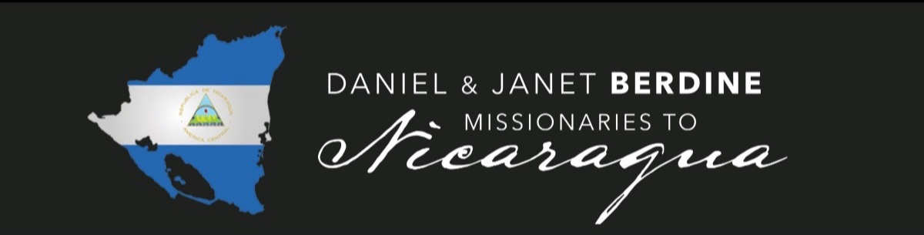

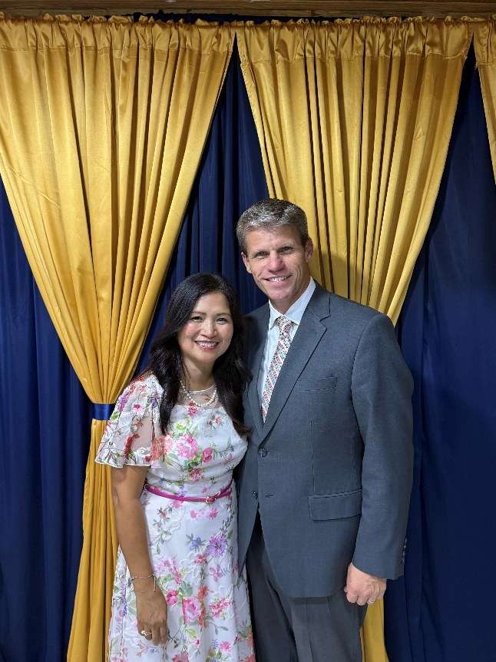

July 23, 2026
Dear Partners in Ministry,
Greetings from Nicaragua!
God continues to do amazing things here in the country. The demands of ministry are great, and they keep my wife and me very busy. But we praise the Lord for the many opportunities He has given us.
As I was reading the Scriptures the other day, I was reading Matthew 11:3, where John the Baptist sent two of his disciples to ask if Jesus was the one, or should they look for another. This Scripture always amazes me. It reminds us of how discouraged we can become. But Jesus is so gracious! He tells them to return and show John again all the things that He does. The blind receive their sight, the lame walk, the lepers are cleansed, the deaf hear, the dead are raised, and the poor have the gospel preached to them.
This is such a wonderful reminder to us. It sometimes seems that everything in the world is bad, everything is falling apart, and all the news we hear is negative. But I just want to encourage you a little: Jesus is coming back! Here in Nicaragua, we are seeing souls saved every week, young men are being trained for ministry, pastors are starting churches from their churches, young people are surrendering to the ministry, and the fields are white unto harvest. God is still at work! Don't get discouraged. God is still in control.
We just finished our first semester for 2026. July is our break between semesters. Classes will resume the first week of August. We are grateful for the break. It has been a busy year. God has allowed us to have nine pastors from the States come to teach in the Bible college. What a blessing this is to our students, and we are grateful to God for the sacrifice these pastors have made to come. We have hosted several pastors' and wives' fellowships, preaching conferences, and marriage conferences. We currently have 21 students in the Bible college. Four of those students are starting churches. We praise God for the opportunity.
Please continue to pray for our family. My wife continues to serve so faithfully and ministers to the ladies and pastors' wives. Please pray for daily strength. One of her gifts is hospitality, and she works very hard hosting so many visitors. Her dedication and endurance always amaze me. Our youngest son, Nick visited with us a couple weeks. God used him greatly while he was here. Valerie, our daughter, is currently with us. Please pray that God will bless her time here. It's such an encouragement to have them here. Our son Nathaniel and his wife, Hannah, will visit in September. He will be teaching in the Bible college. We praise God for our family.
We are very grateful for all your prayers and faithful support. May God richly bless each of you. May we continue to serve the Lord Jesus Christ until He returns.
Because of Calvary,
Daniel and Janet Berdine
Missionaries to Nicaragua
Cell: 937-417-8413

Answered Prayers:
- Souls have been saved through recent evangelistic efforts.
- 4 new church plants through young men in the Bible college
Prayer & Giving Opportunities:
- Support for National Pastors
- The new Church Plant in San Antonio Sur in 2026. Please pray for the salvation of souls, for God to raise up a pastor to lead, and for the provision of equipment and a meeting place.
- Janet's health
- Our 3 children, Valerie, Nathaniel and his wife Hannah, and Nick
- Safety as we travel throughout the country
- The hearts of the people to continue to be receptive to the Gospel

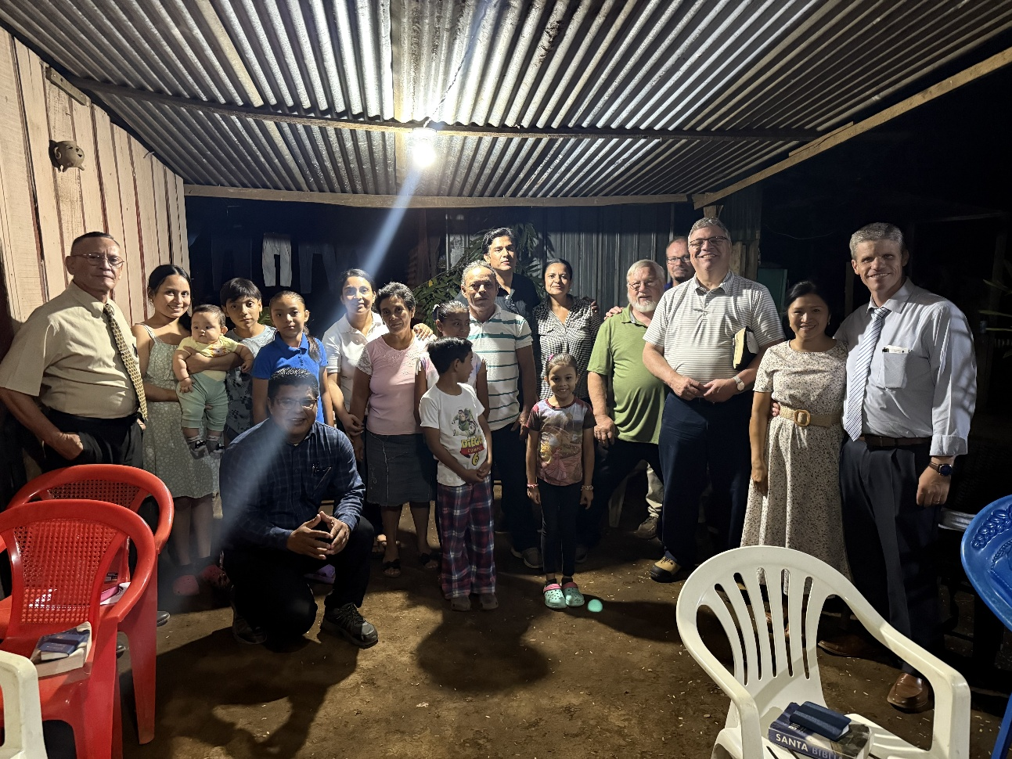
Praise the Lord a new body of believers are being assembled into a local church in our community!

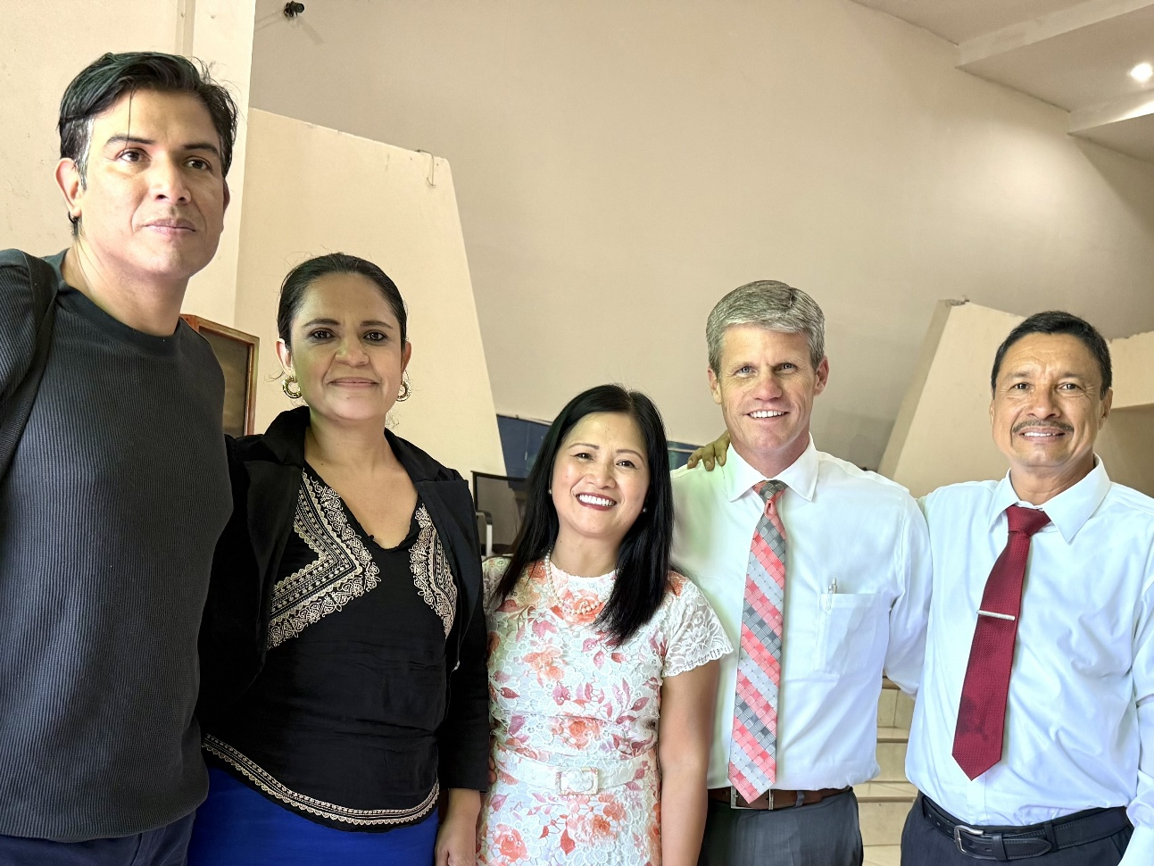
This couple have been saved and they followed the Lord in Baptism

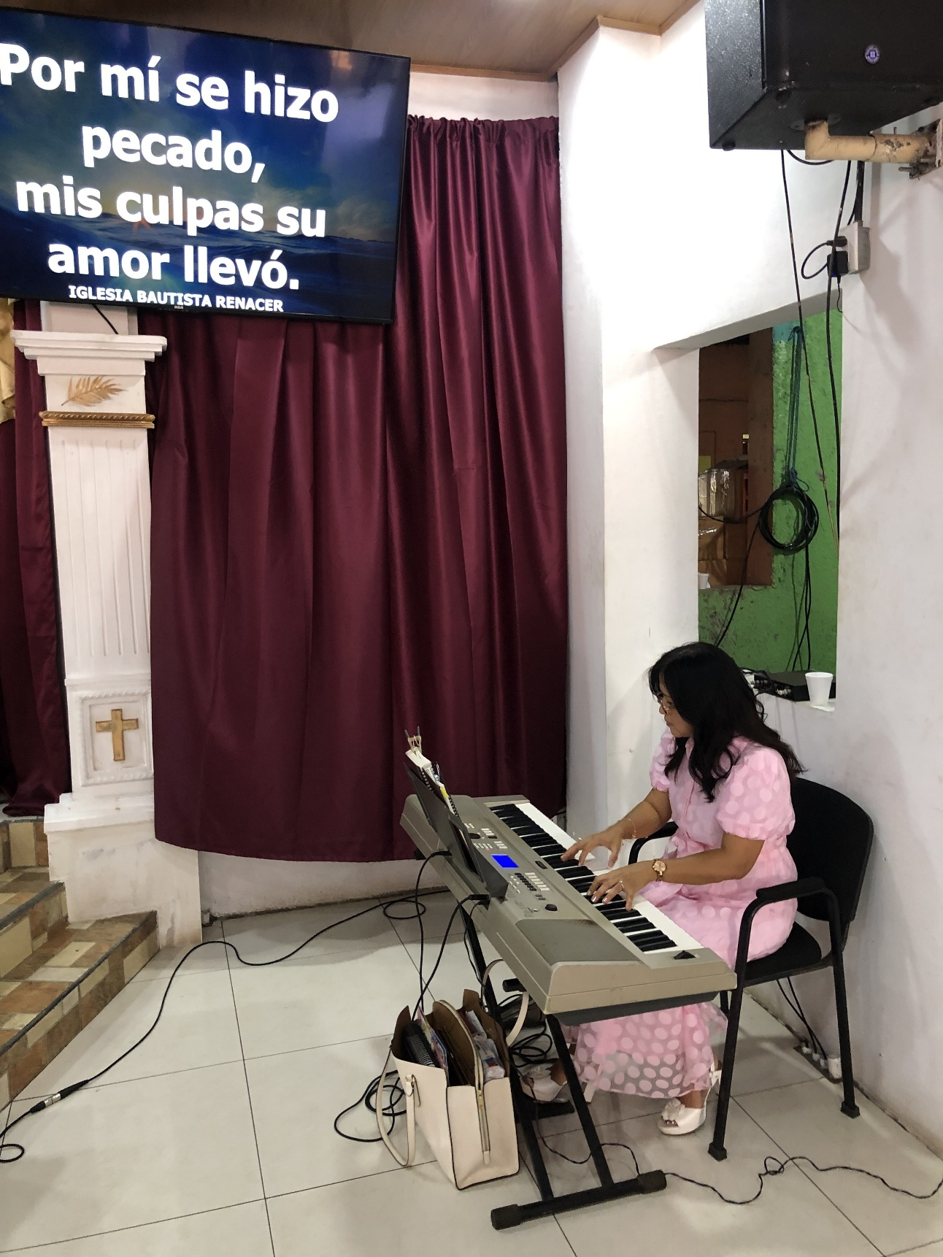

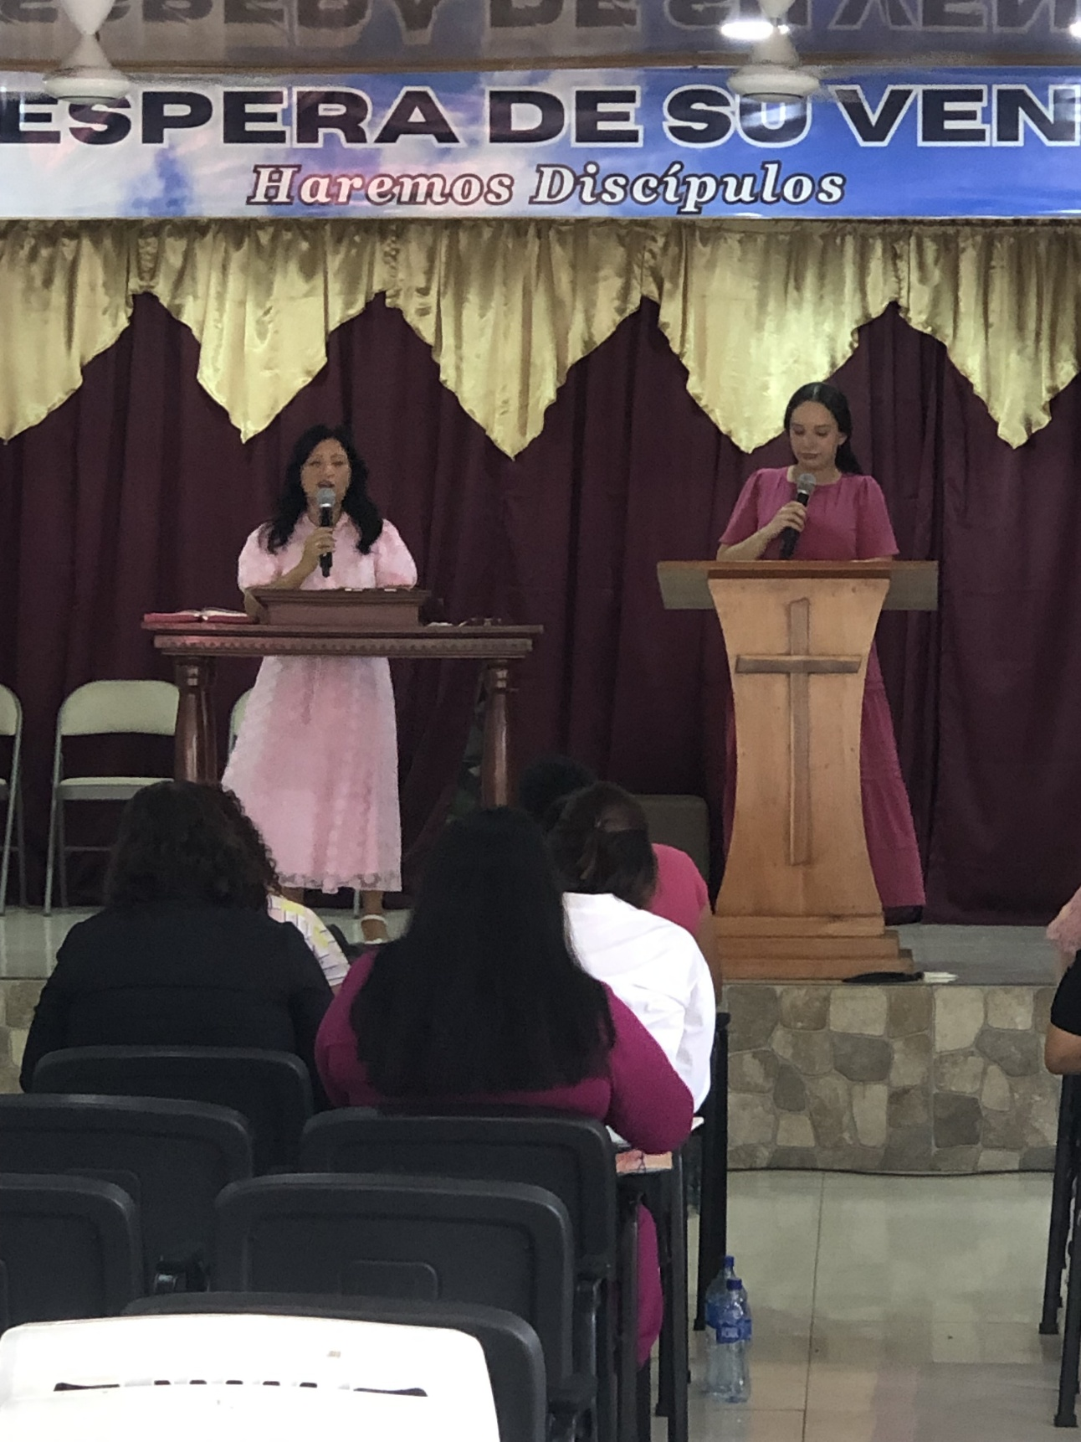
With the Lord's help, Janet and I were able to have a Marriage conference in April. Our guest teacher was Rick Carter. He and His wife helped us with the meeting

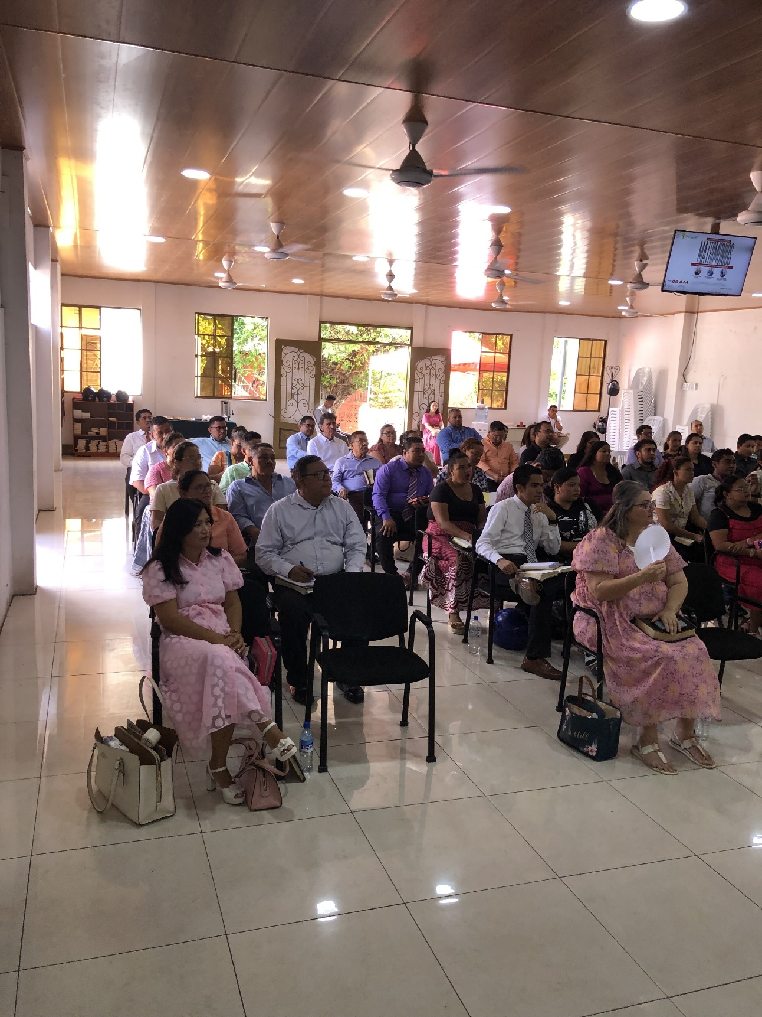

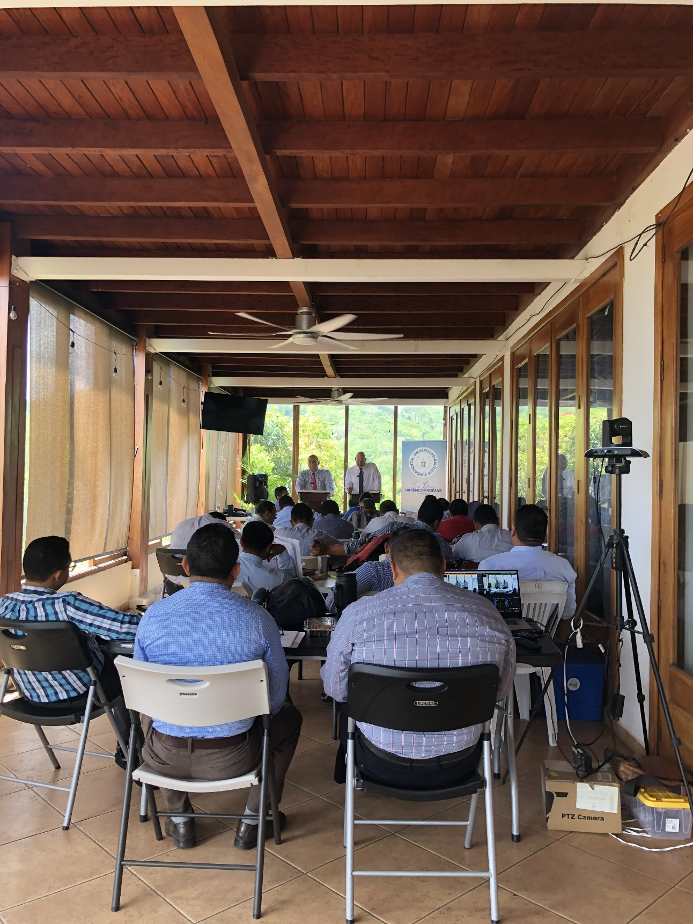

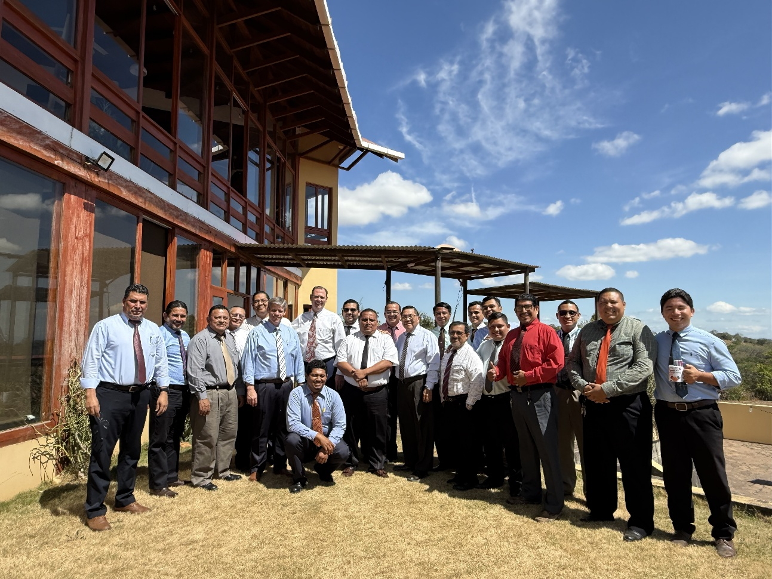
Above is the Bible college God has so graciously allowed us to start last year. What a great opportunity to equip Pastors and train the young men. We now have 21 Students.
Below is just a little insight to what my wife puts into this ministry, from preparing meals, to hosting Pastor's wives, playing piano, speaking to ladies. You name it, she does it! What a blessing she is!

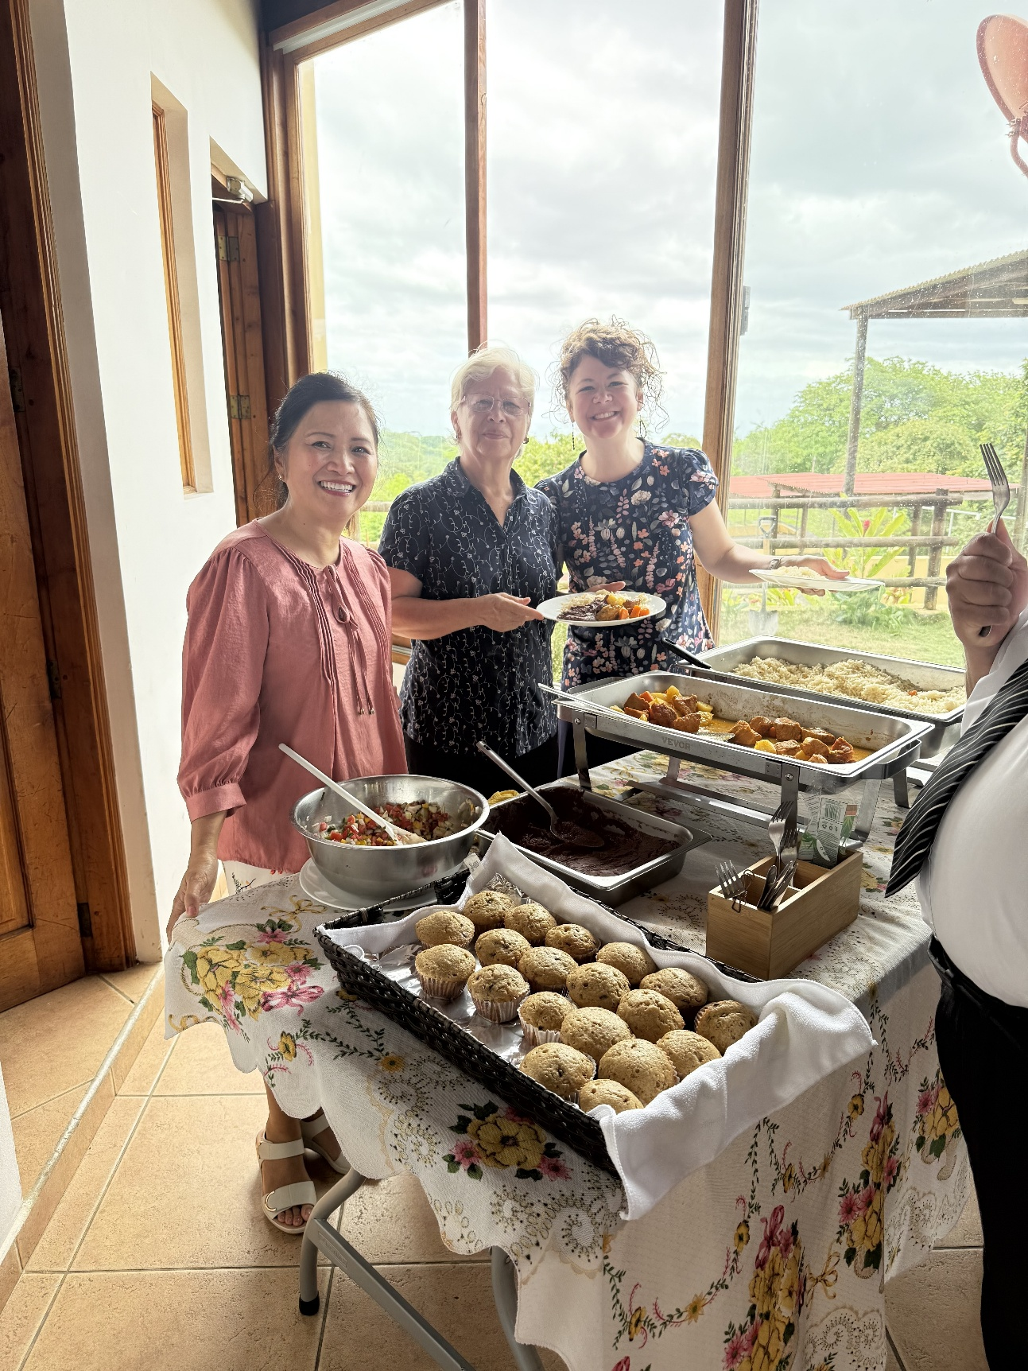

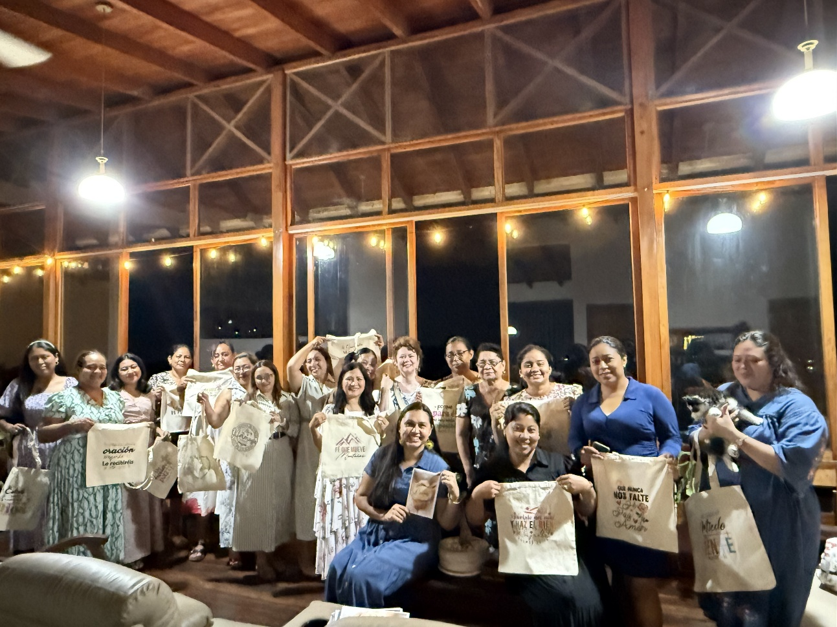

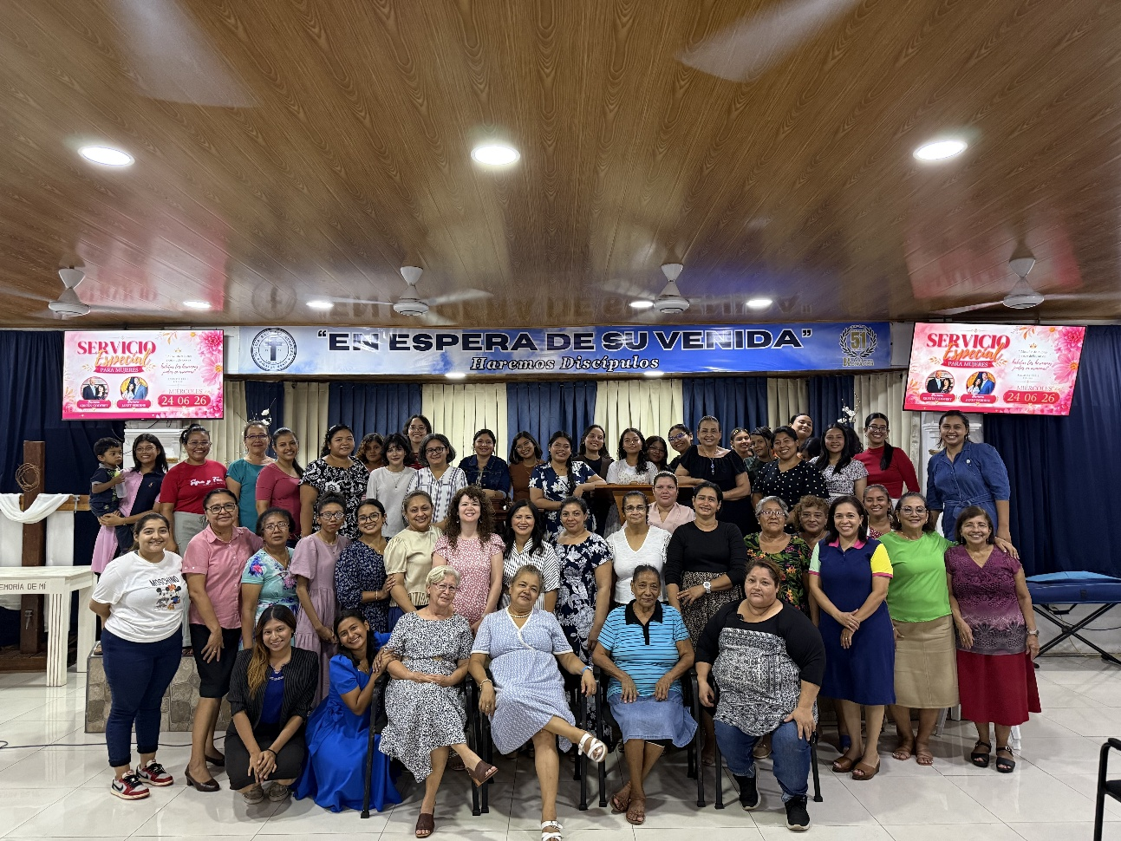

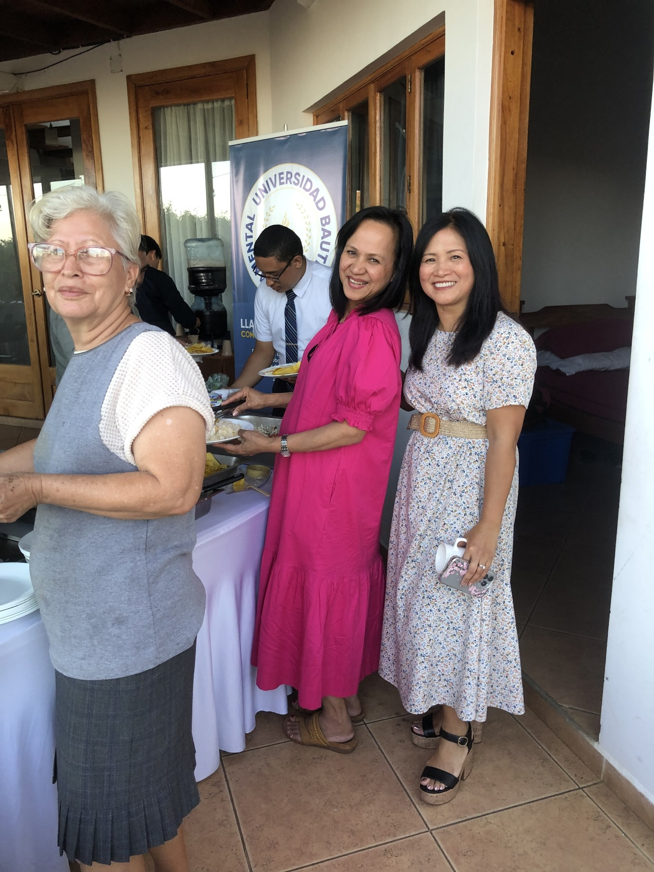
God gave us the opportunity to minister at a teen camp hosted by 5 churches. I had the opportunity to speak twice. God blessed in an amazing way. Many young people surrendered to serve the Lord. Please pray for this group of young people!

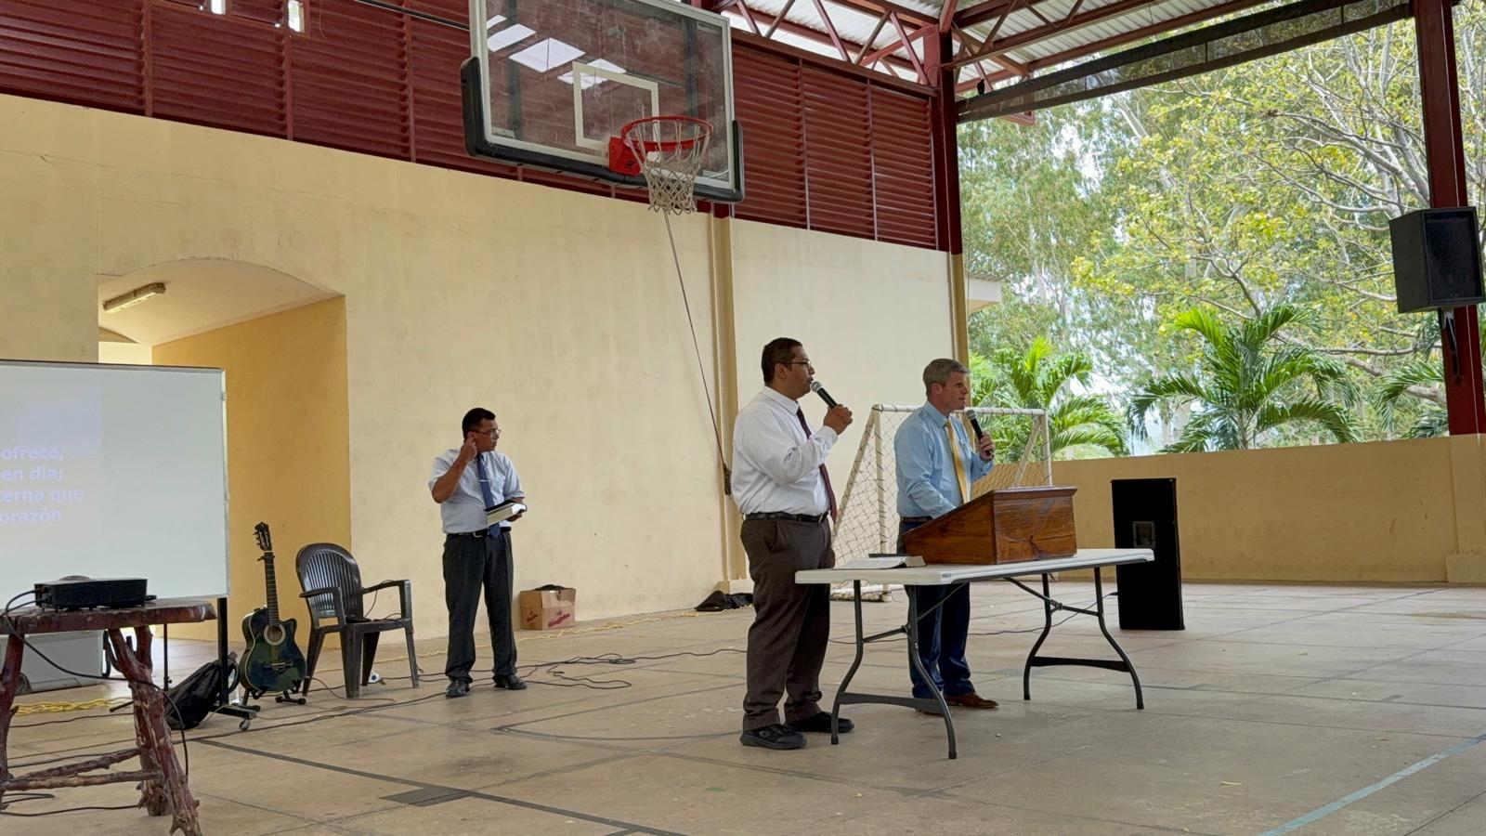

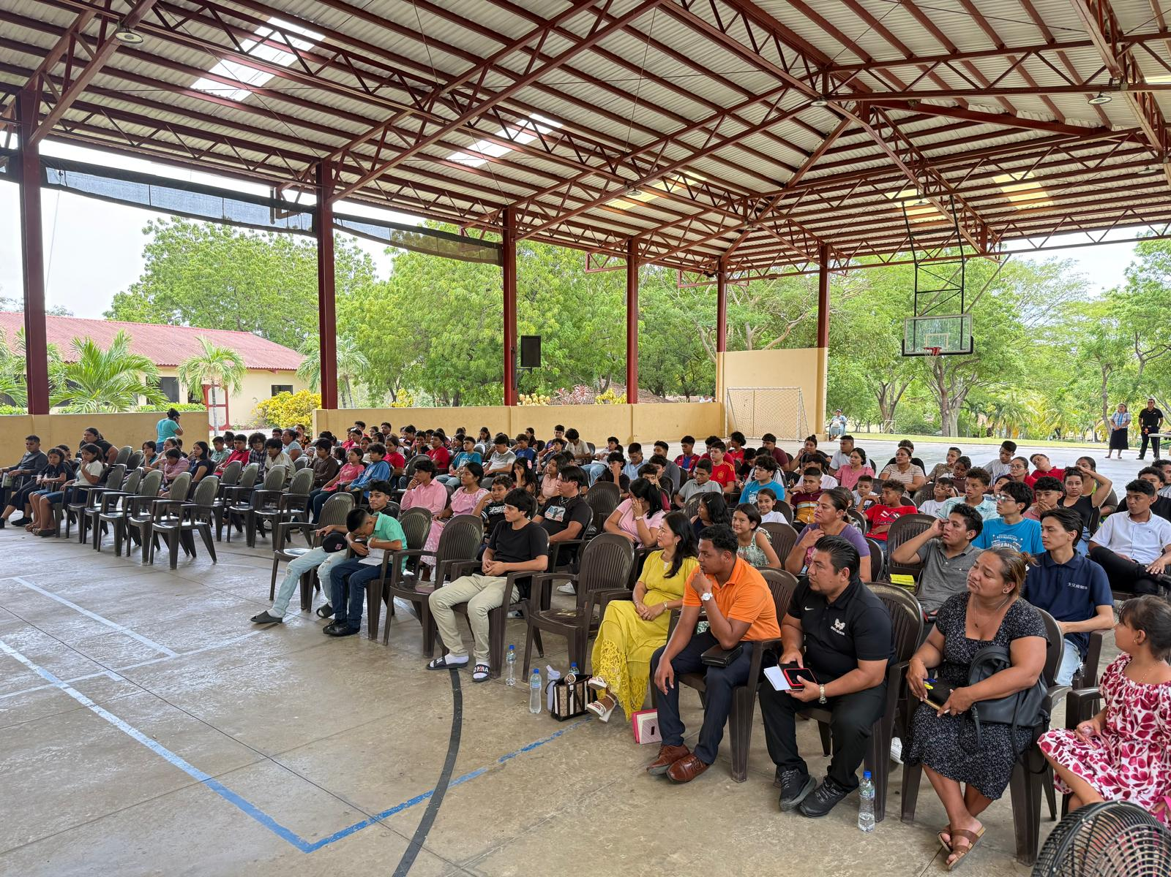

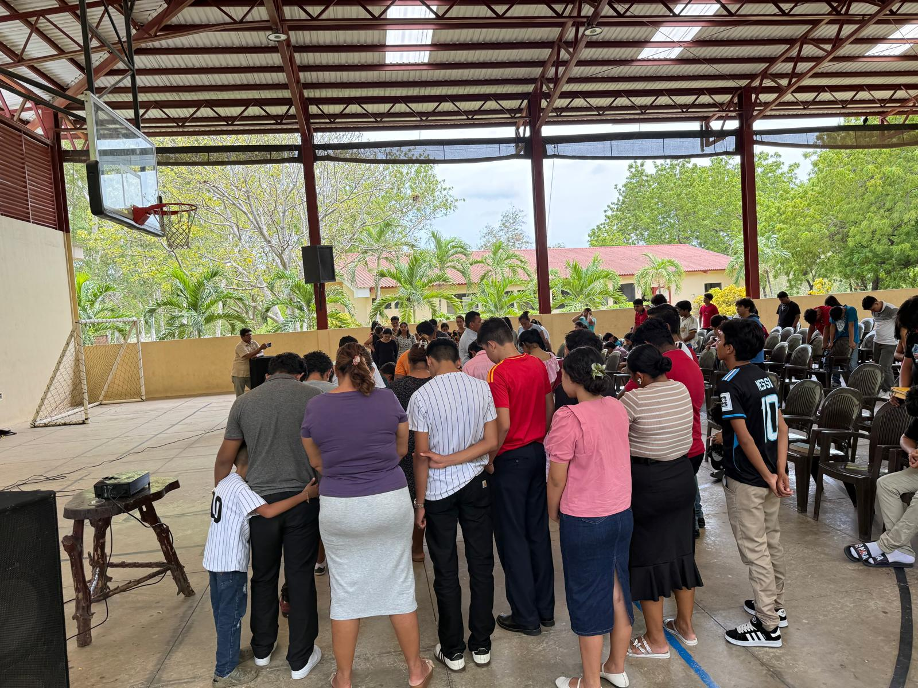
God continues to save souls! Praise the Lord Saul received Christ as His Saviour! Please pray for this young man!

